**NATIONAL UNIVERSITY OF COMPUTER AND EMERGING SCIENCES CL 103 - COMPUTER PROGRAMMING LAB**

**Instructors:** Ms. Farah Sadia

**Email:** farah.sadia@nu.edu.pk



**Lab # 03**

**Outline**

* Classes
* Objects
* Structures VS Classes
* Transformation from Procedural to Object Oriented Programming
* Example Programs
* Exercise

**CLASSES**

A class is a programmer-defined data type that describes what an object of the class will look like when it is created.

It consists of a set of variables and a set of functions.

Classes are created using the keyword **class**. A class declaration defines a new type that links code and data. This new type is then used to declare objects of that class.

In the UML, a class icon can be subdivided into compartments. The top compartment is for the name of the class, the second is for the variables of the class, and the third is for the methods of the class.

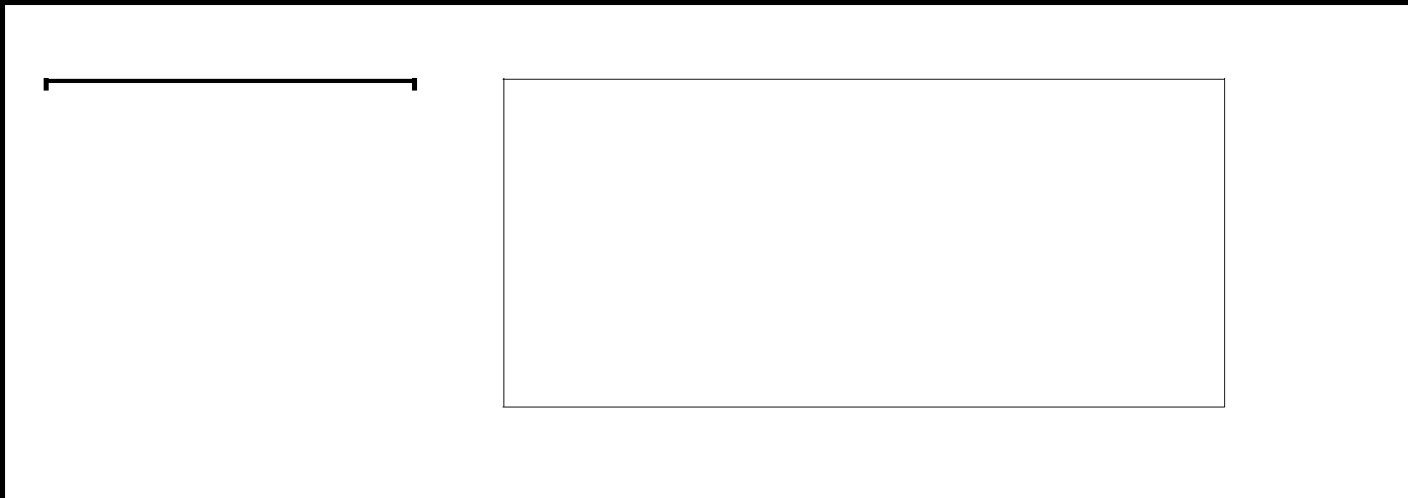

**CLASS NAME**

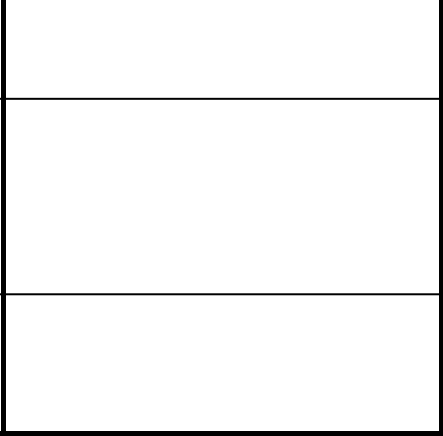

**Data Members**

**Or Variables**

**Member Functions**

**class *class-name***

***{***

***access-specifier:***

***data***

***access-specifier: functions***

***};***

CLASS NAME

By convention, the name of a user-defined class begins with a capital letter and, for readability, each subsequent word in the class name begins with a capital letter.

DATA MEMBERS

Consider the attributes of some real world objects:

**RADIO** –station setting, volume setting.

**CAR** –speedometer readings, amount of gas in its tank and what gear it is in.

These attributes form the data in our program. The values that these attributes take (the blue color of the petals, for example) form the state of the object.

MEMBER FUNCTIONS

Consider the operations of some real world objects:

**RADIO** – setting its station and volume (invoked by the person adjusting the radio’s controls)

**CAR** –accelerating (invoked by the driver), decelerating, turning and shifting gears. These operations form the functions in program. Member functions define the class’s behaviors.

**OBJECTS**

In C++, when we define a variable of a class, we call it **instantiating** the class. The variable itself is called an **instance** of the class. A variable of a class type is also called an **object**. Instantiating a variable allocatesmemory for the object.

**RADIO** r;

**CAR** c;

**Structures VS Classes**

By default, all structure fields are public, or available to functions (like the main() function) that are outside the structure. Conversely, all class fields are private. That means they are not available for use outside the class. When you create a class, you can declare some fields to be private and some to be public. For example, in the real world, you might want your name to be public knowledge but your Social Security number, salary, or age to be private.

**TRANSFORMATION FROM PROCEDURAL TO OBJECT ORIENTED PROGRAMMING**

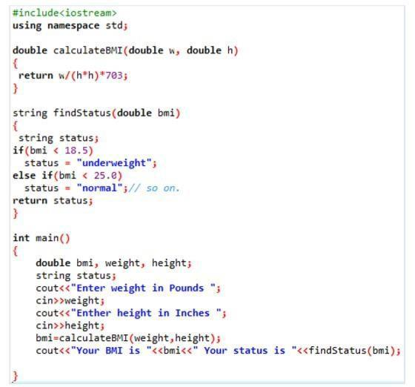

**Procedural Approach**

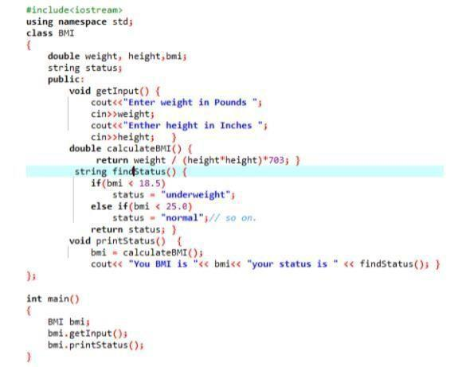

**Object Oriented Approach**

**EXAMPLE PROGRAM**

**#include<iostream>**

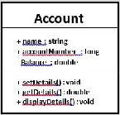

**using namespace std;**

**class Account**

**{**

**private:**

**double balance; // Account balance public: //Public interface:**

**string name; // Account holder long accountNumber;**

* **Account number void setDetails(double bal)**

**{**



**balance = bal;**

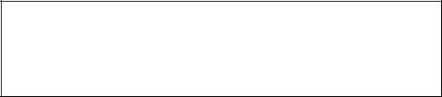

**}**

**Set and get functions to manipulate**

**double getDetails()**

**private data member**

**{**

**return balance;**

**}**

**void displayDetails()**

**{**

**cout<<"Details are: "<<endl;**

**cout<<"Account Holder:**

**"<<name<<endl;**

**cout<<"Account Number:**

**"<<**

**accountNumber <<endl; cout<<"Account**

**Balance: "<<getDetails()<<endl;**

**}**

|  |  |  |
| --- | --- | --- |
| **};** |  |  |
| **int main(){ double accBal; Account** |  |  |
| **currentAccount;** |  |  |
| **currentAccount.getDetails();** |  |  |
| **cout<<"Please enter the details"<<endl;** |  |  |
| **Publically available data:** |  |
| **cout<<"Enter Name:"<<endl; getline(cin,** |  |
| **Assigning values from** |  |
| **currentAccount.name); cout<<"Enter** |  |
|  |  |
| **Account Number:"<<endl;** |  |  |
|  |  |
| **cin>>currentAccount.accountNumber;** |  |  |



|  |  |  |  |  |
| --- | --- | --- | --- | --- |
| **cout<<"Enter Account** |  |  |  |  |
| **Balance:"<<endl; cin>>accBal;** |  |  |  |  |
| **currentAccount.setDetails(accBal);** |  | **Private data:** |  |  |
|  |  |  |
| **cout<<endl;** |  |  |  |
|  | **Accessing private data using member function** |  |  |
| **currentAccount.displayDetails();** |  |  |  |
|  |  |  |  |
| **return 0;** |  |  |  |  |
| **}** |  |  |  |  |

